S3 Bucket

Static web site hosting on s3 bucket

🡺 create bucket

After Creating bucket upload index.html or image files into bucket

🡺bucket-name🡺upload

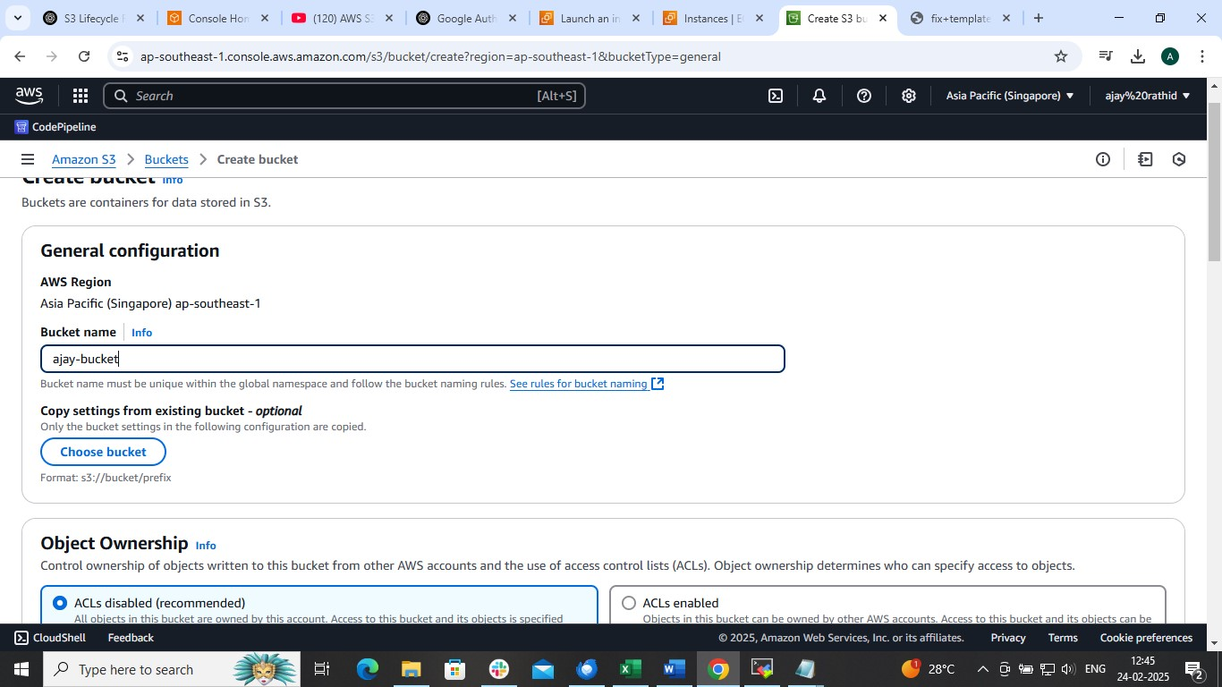

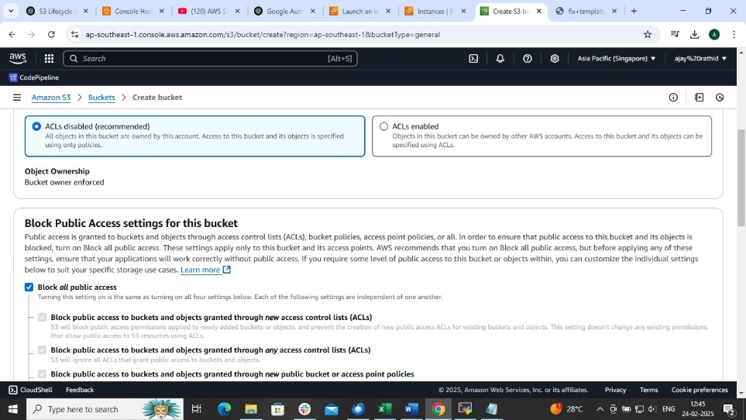

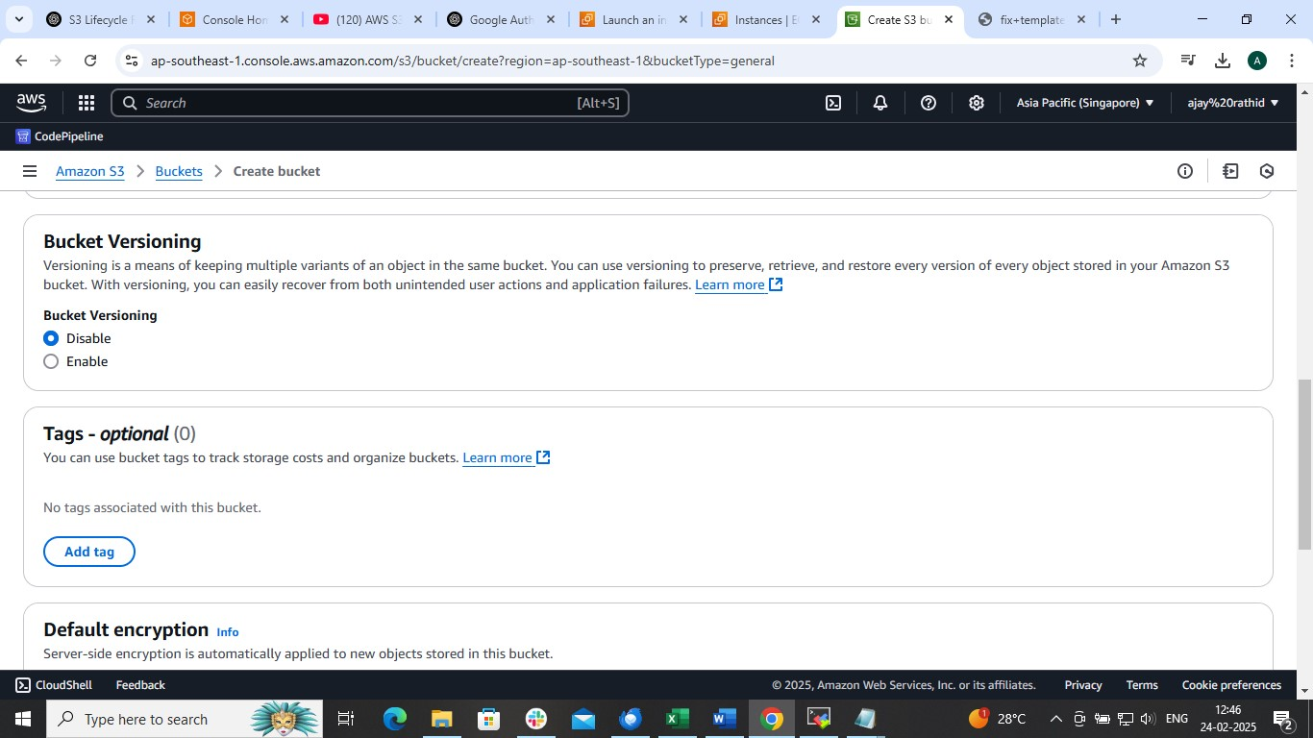

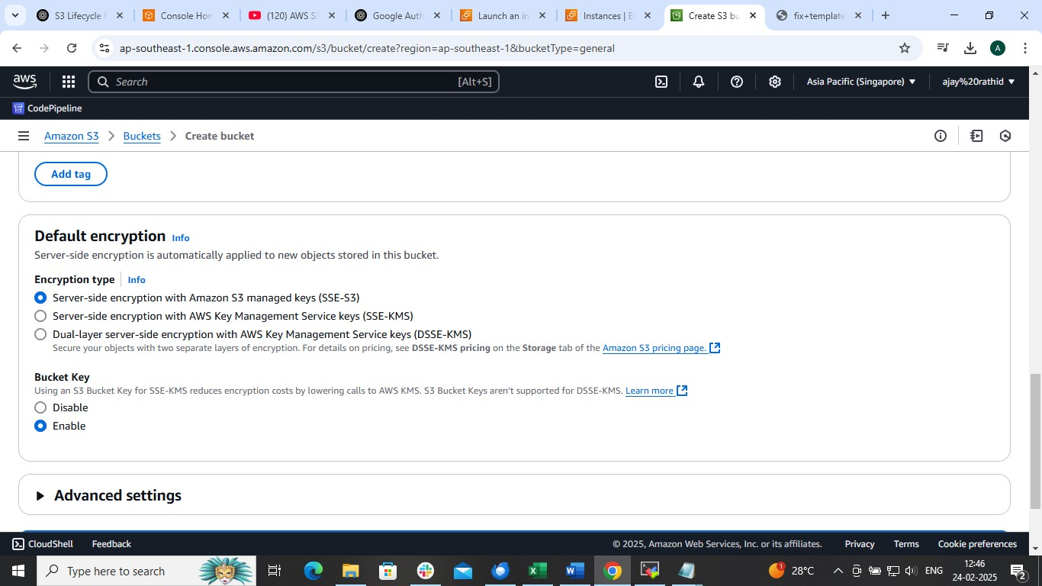

In Encryption we choose amazon s3 managed key or

Aws key management service key

If we choose Aws key management service key then need to follow following steps OTHERWISE PROCED WITH DEFAULT ONE

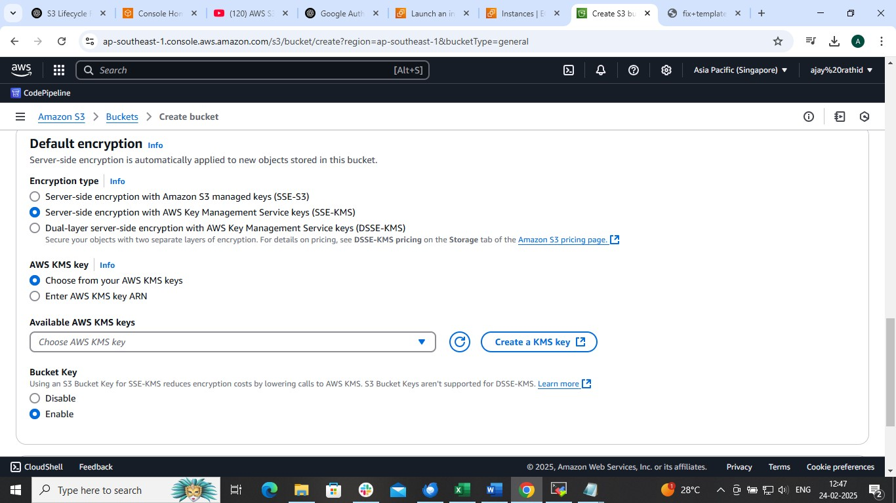

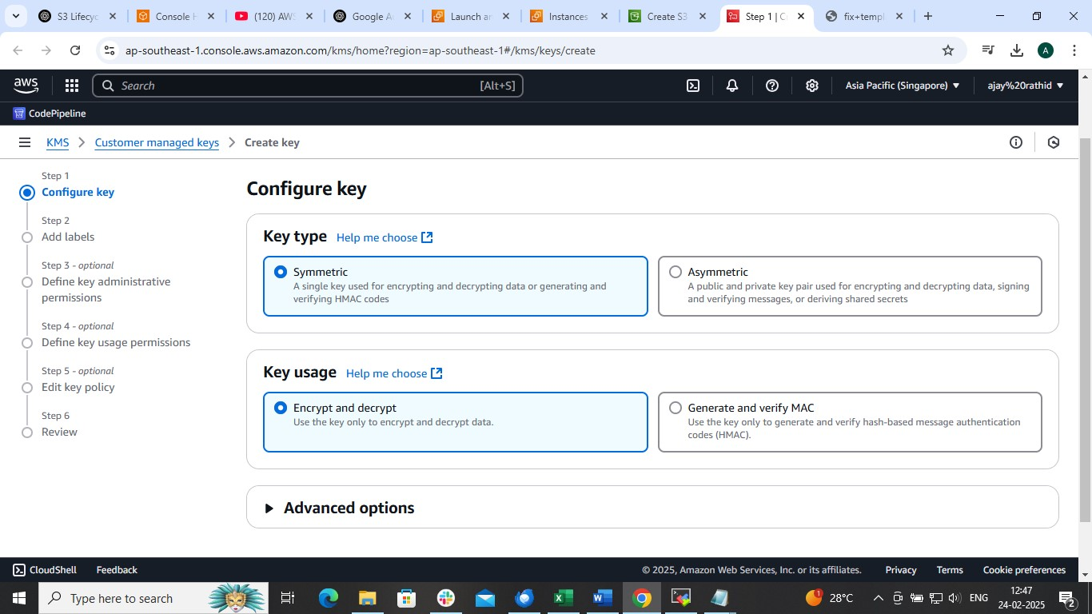

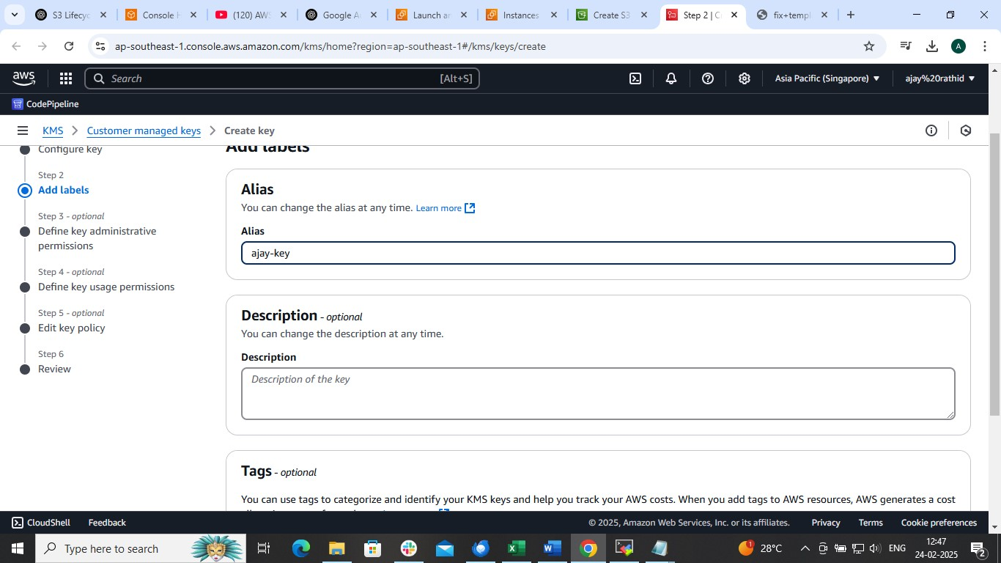

IF NOT THEN 🡺 AMAZON KEY MANAGEMENT SERVICE

* Create Bucket
* 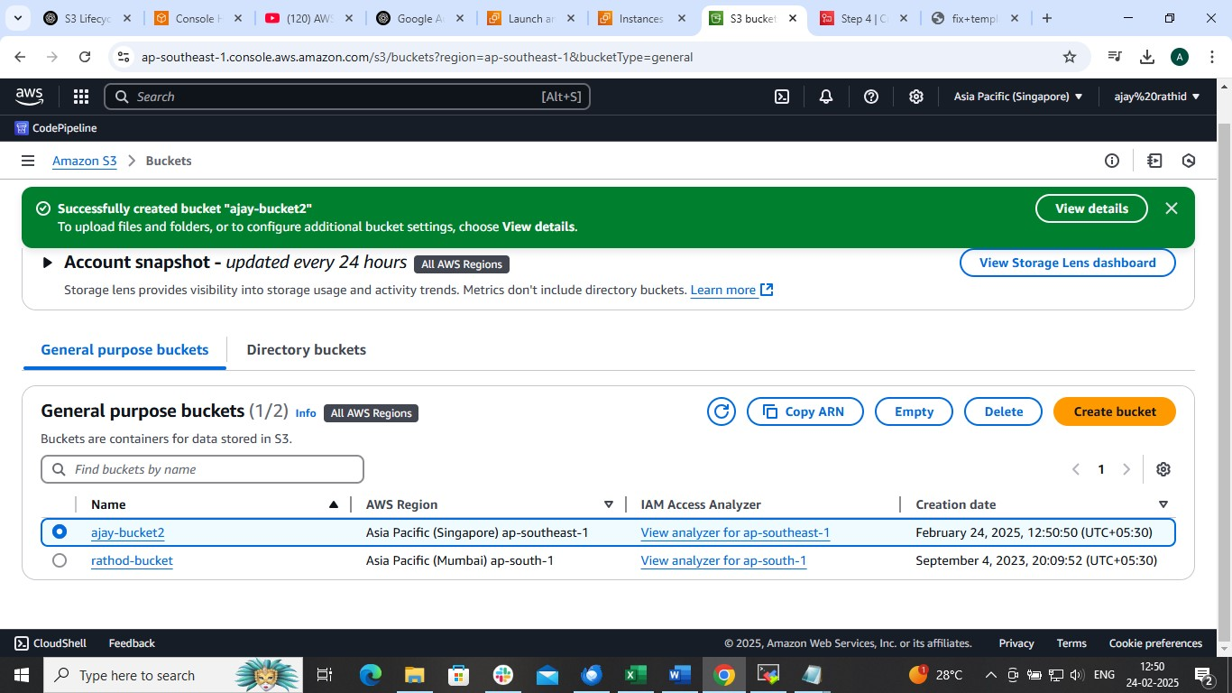
* 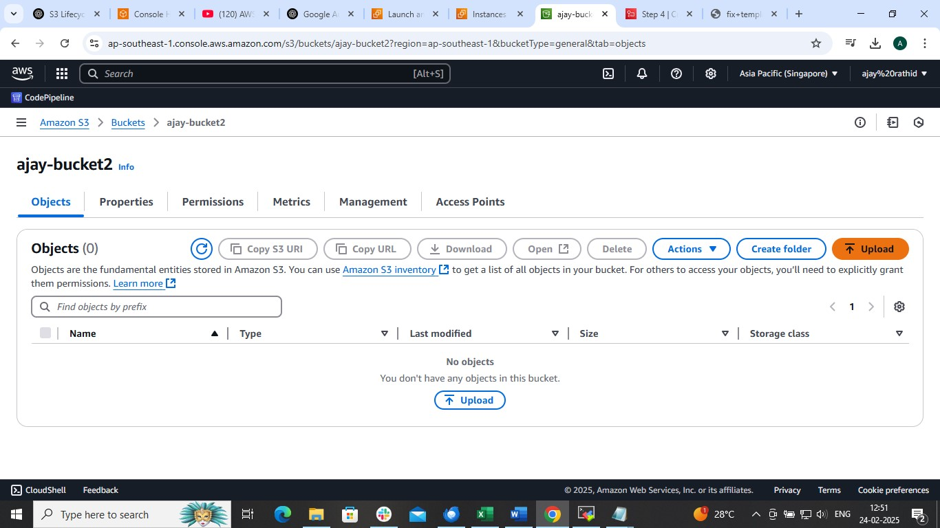

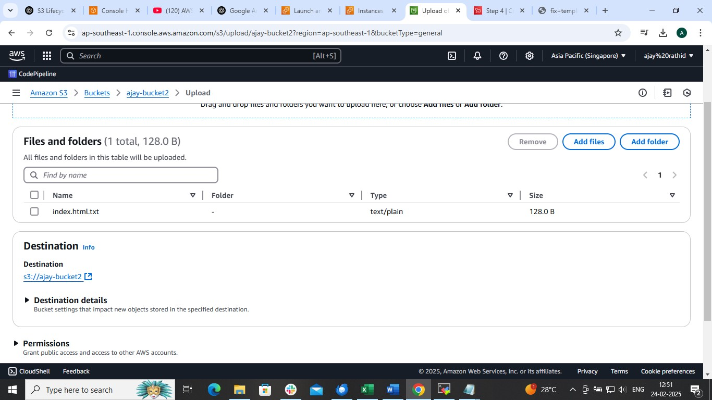

AFTER ADDING OBJECT

Copy the url path of object and paste in browser

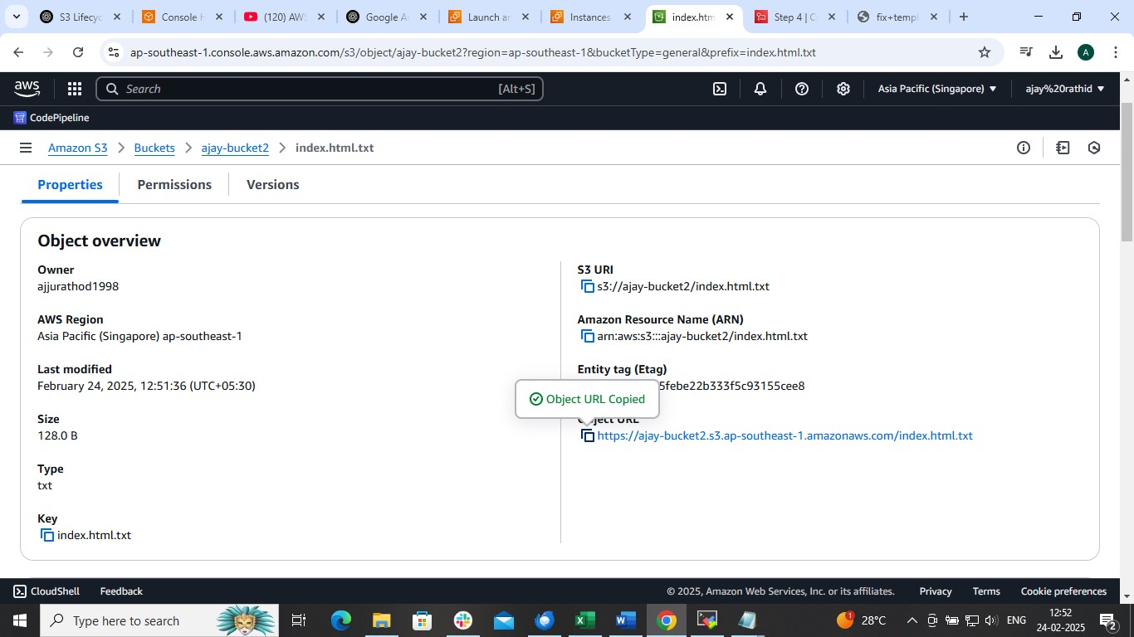

Error will occur

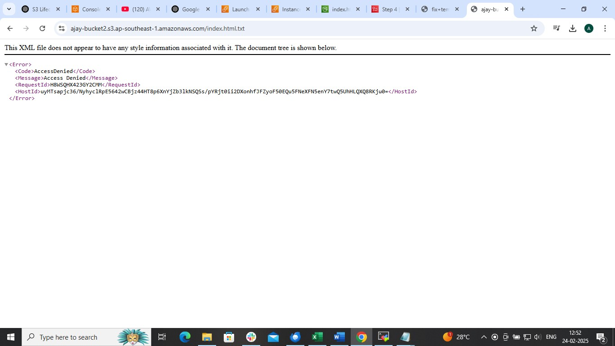

To resolve this

1 . Enable static web hosting

2 . Untick public block access

3 . And attach bucket policy

1.Enable static hostig

🡺bucket-name🡺properties

Enable static web hosting

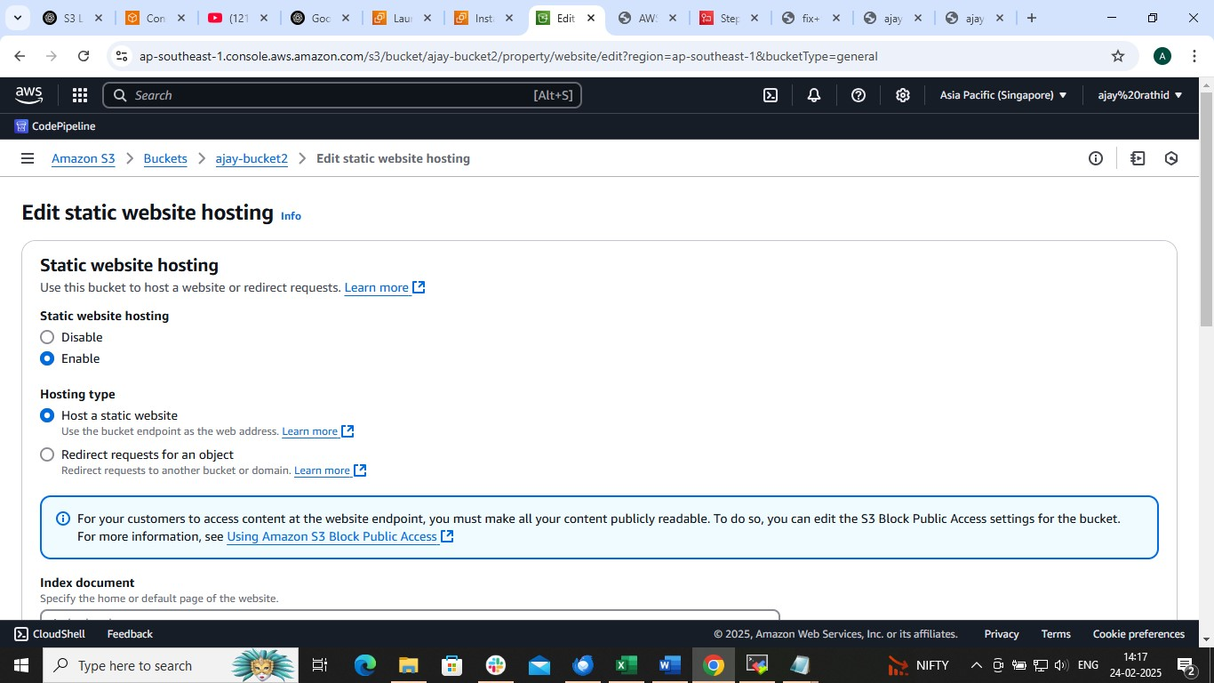

2. Untick the public access

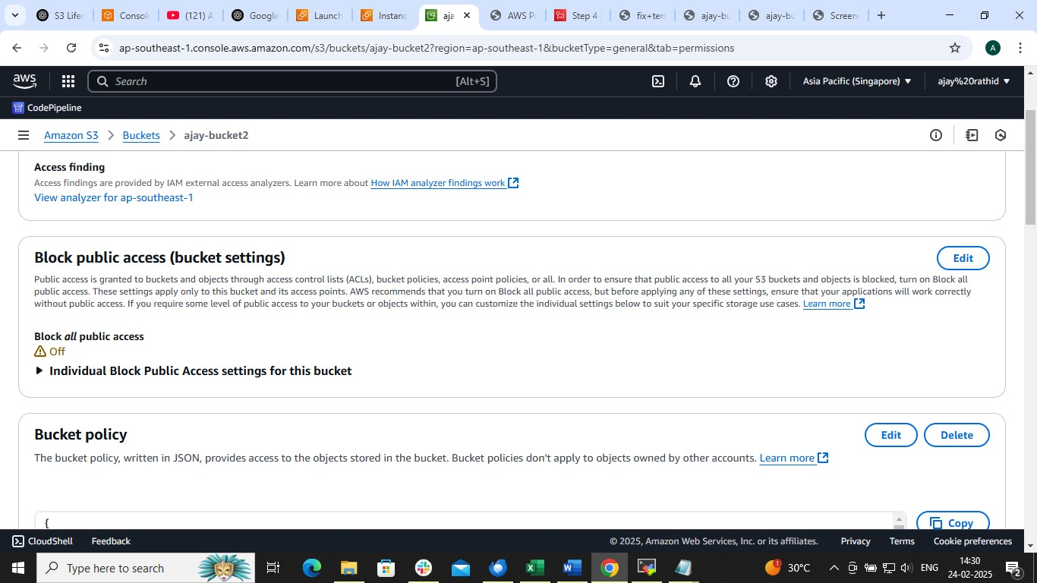

3. Attach a bucket policy

{

"Version": "2012-10-17",

"Statement": [

{

"Sid": "Statement1",

"Effect": "Allow",

"Principal": "*",

"Action": [

"s3:GetObject",

"s3:ListBucket",

"s3:PutObject"

],

"Resource": [

"arn:aws:s3:::ajay-bucket2",

"arn:aws:s3:::ajay-bucket2/*"

]

}

]

}

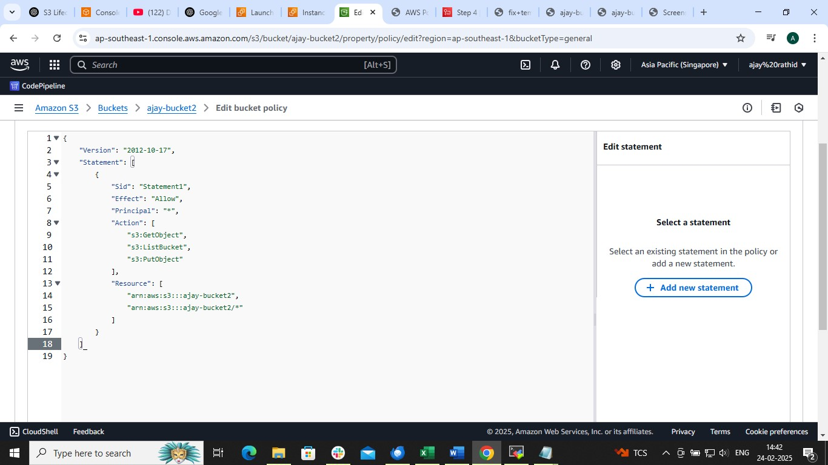

And Copy the url of object and access through browser

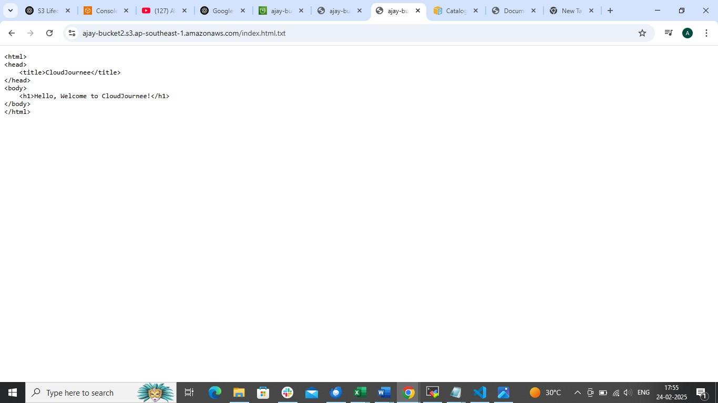

Performing acting through AWS CLI

Launch ec2 instance and configure it

Use google to install aws cli into linux server

curl "https://awscli.amazonaws.com/awscli-exe-linux-x86_64.zip" -o "awscliv2.zip"

unzip awscliv2.zip

sudo ./aws/install

curl "https://awscli.amazonaws.com/awscli-exe-linux-x86_64.zip" -o "awscliv2.zip"

unzip awscliv2.zip

sudo ./aws/install --bin-dir /usr/local/bin --install-dir /usr/local/aws-cli –update

curl "https://awscli.amazonaws.com/awscli-exe-linux-x86_64.zip" -o "awscliv2.zip"

unzip -u awscliv2.zip

sudo ./aws/install

sudo ./aws/install --bin-dir /usr/local/bin --install-dir /usr/local/aws-cli –update

which aws

aws –version

next step to configure aws

RUN command

aws configure

It will ask for aws access key and secret key

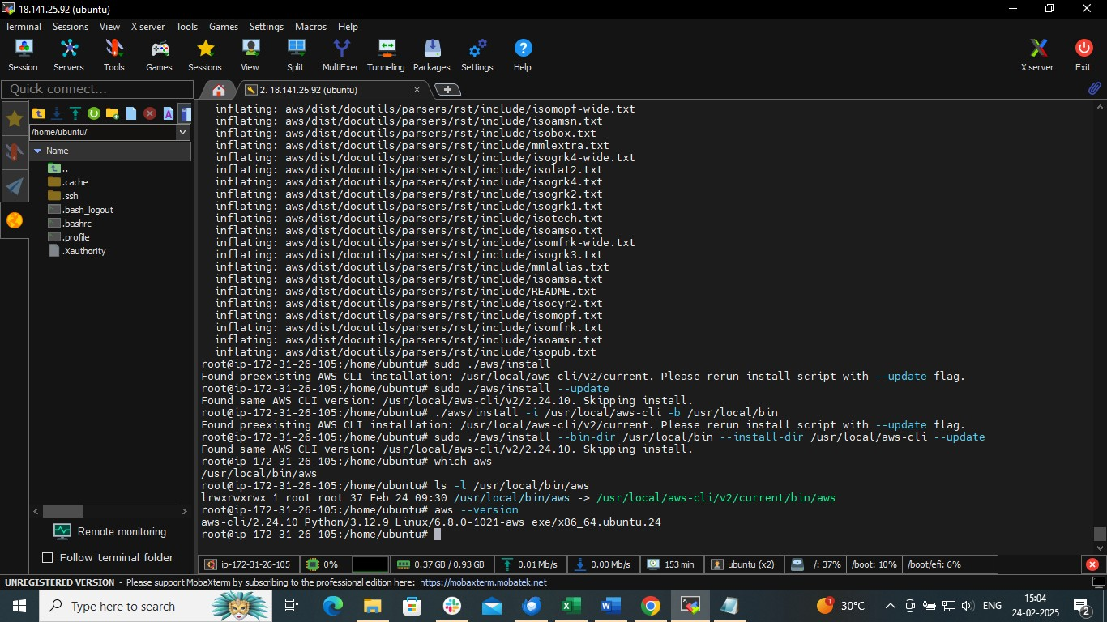

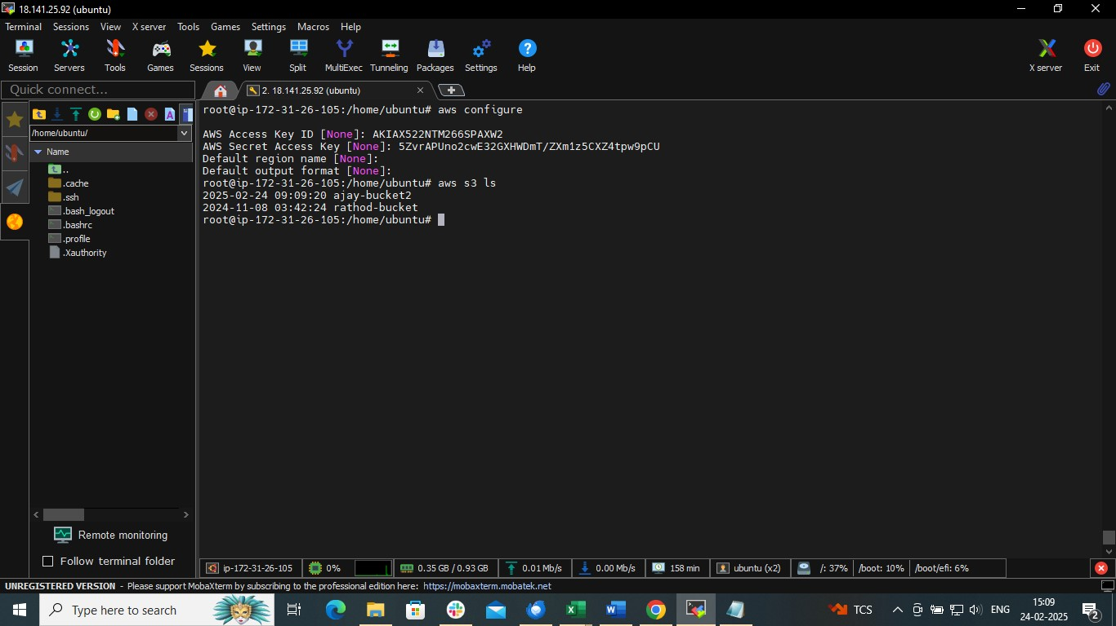

we can perform aws cli command

TO LIST BUCKET

aws s3 ls

TO CREATE A NEW BUCKET

aws s3 mb s3://my-bucket-name

TO LIST THE OBJECT INSIDE BUCKET

aws s3 ls s3://my-bucket-name

TO UPLOAD A FILE TO S3

aws s3 cp myfile.txt s3://my-bucket-name

ETC

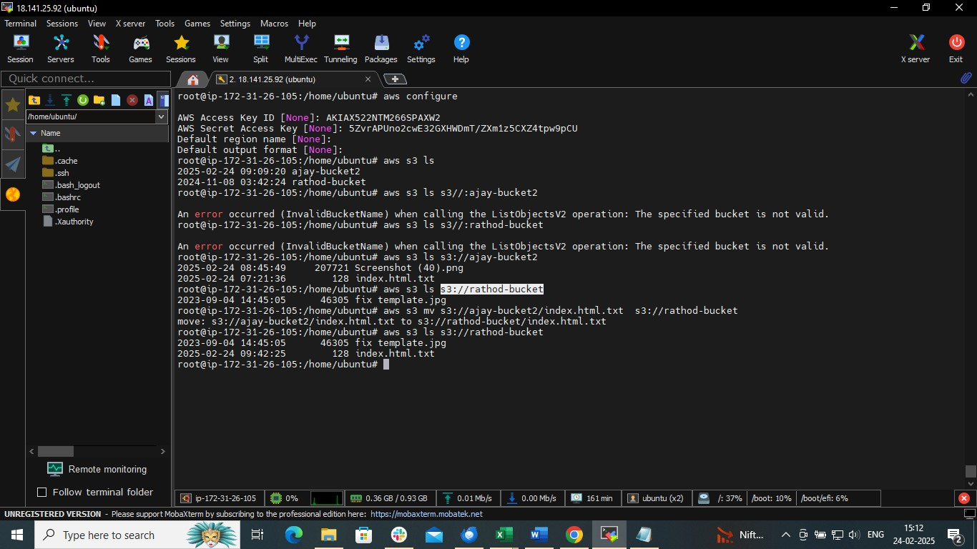

REPLICATION

Create two buckets

* Source bucket
* Destination bucket

🡺source bucket from which you want replicate

🡺bucket🡺management🡺create replication

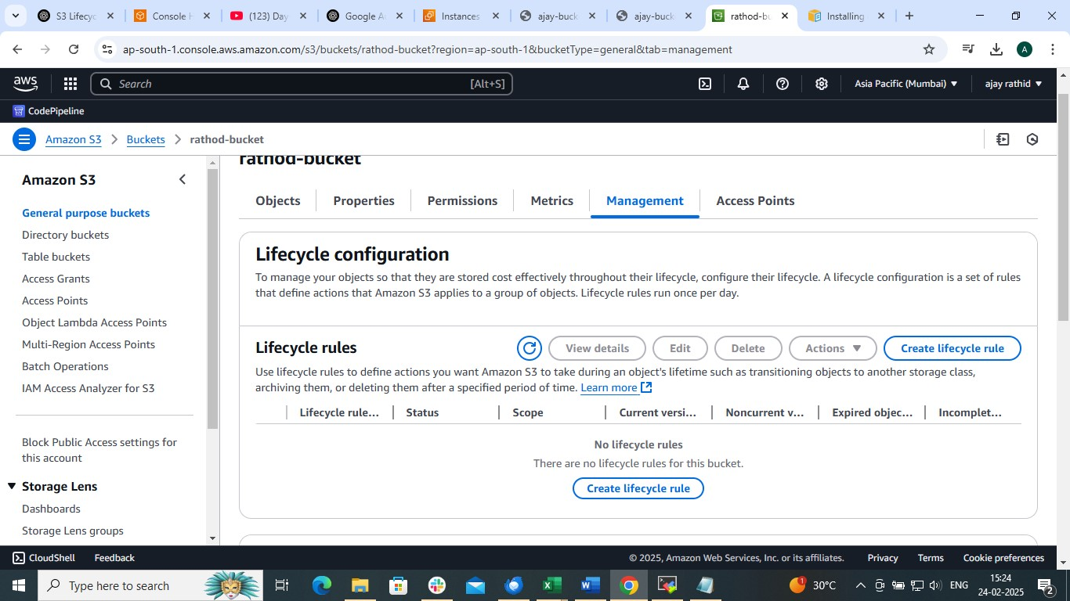

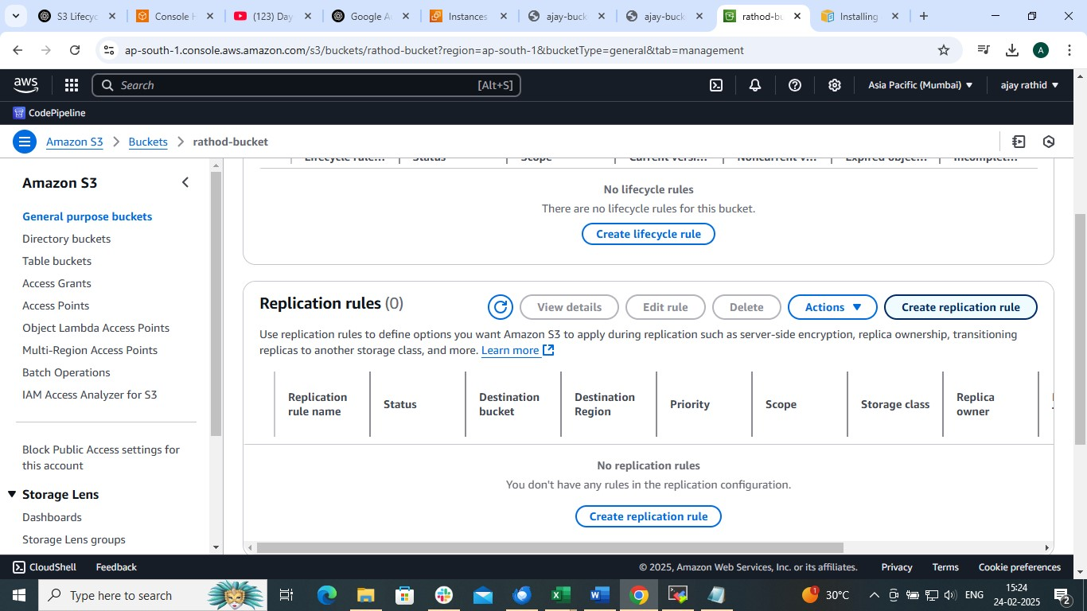

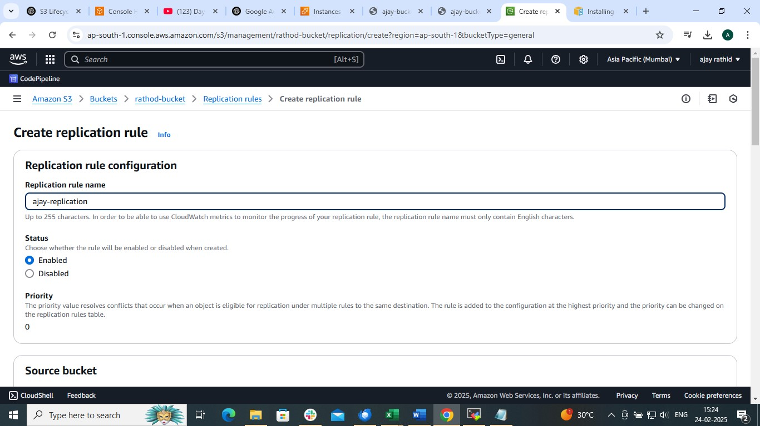

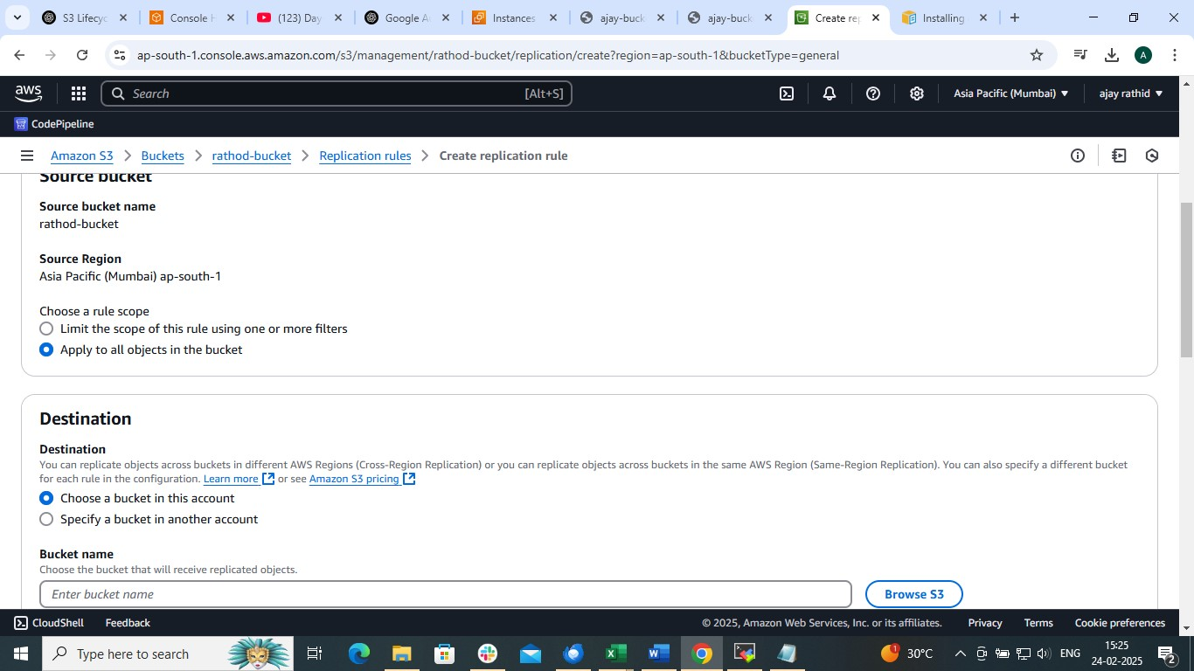

Choose bucket from which we want replicate data (Source Bucket)

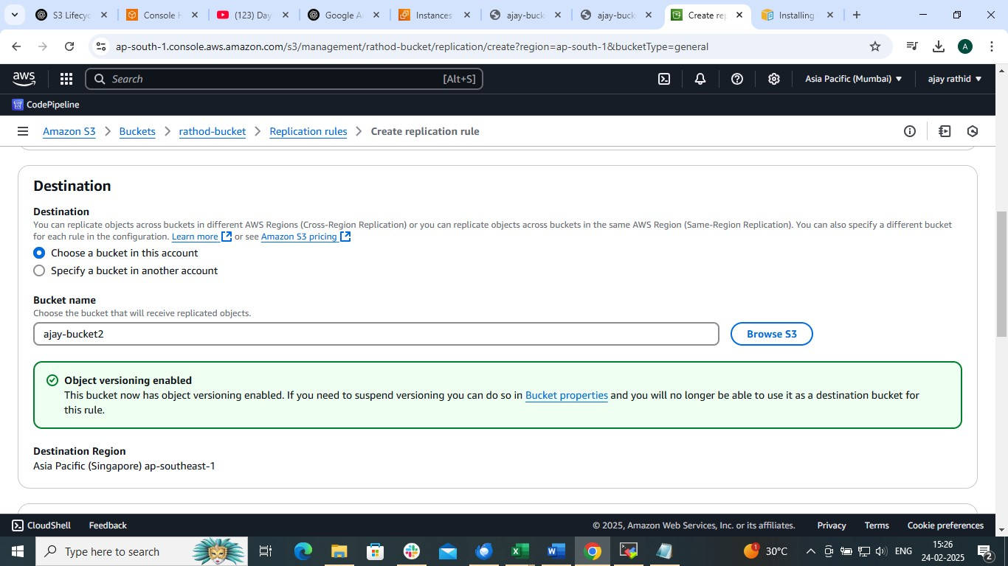

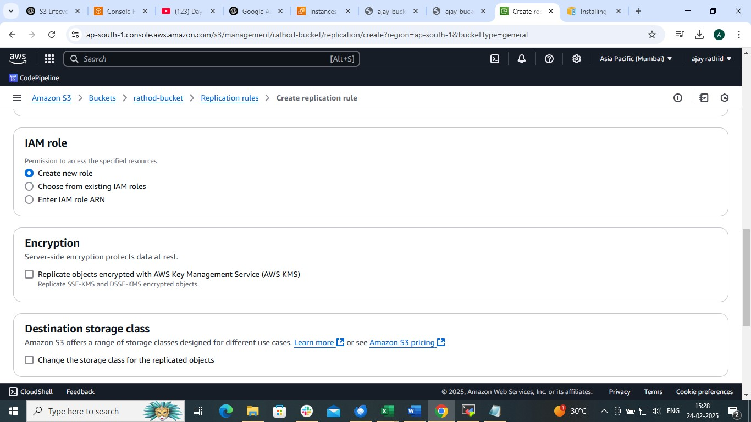

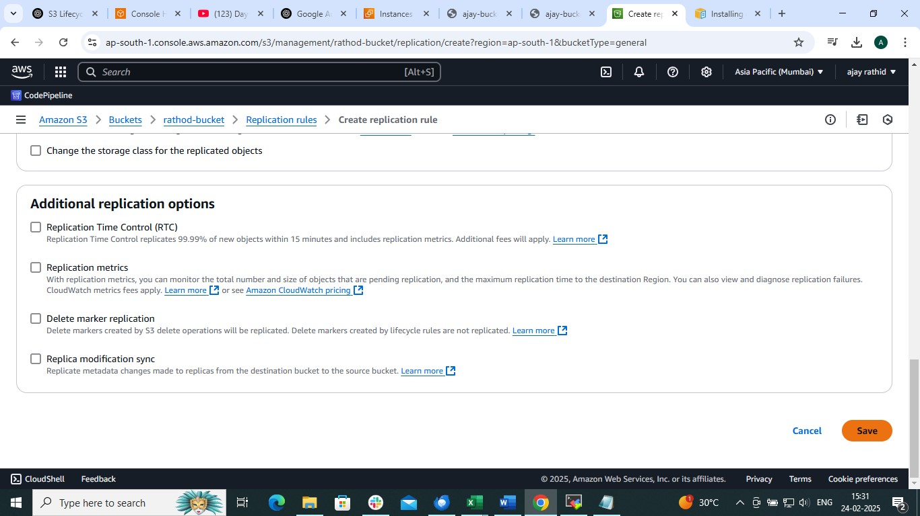

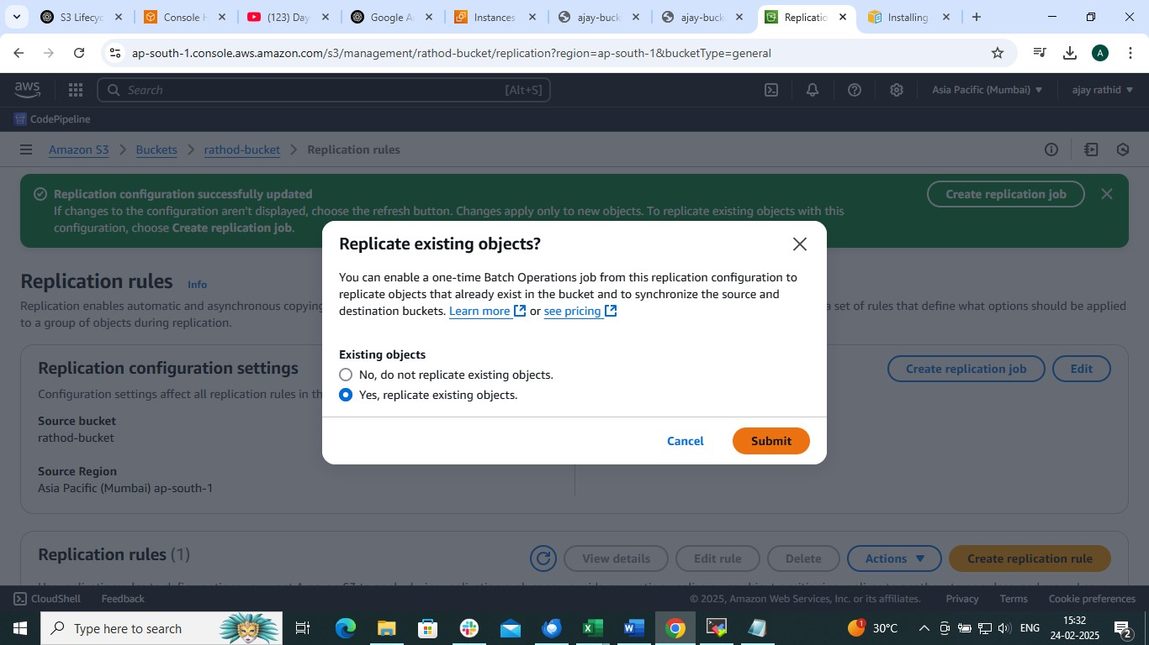

SELECT DESTINATION BUCKET

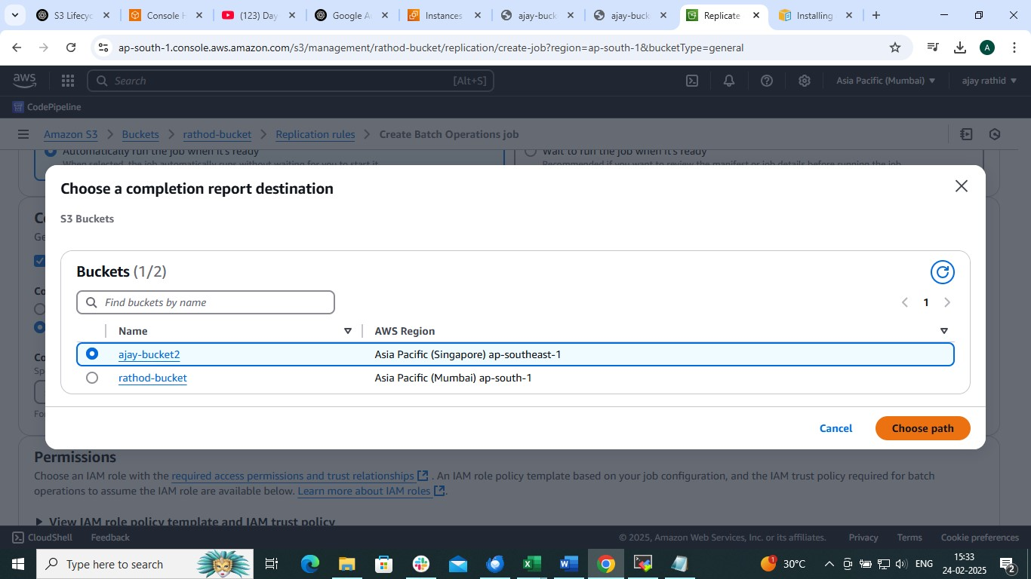

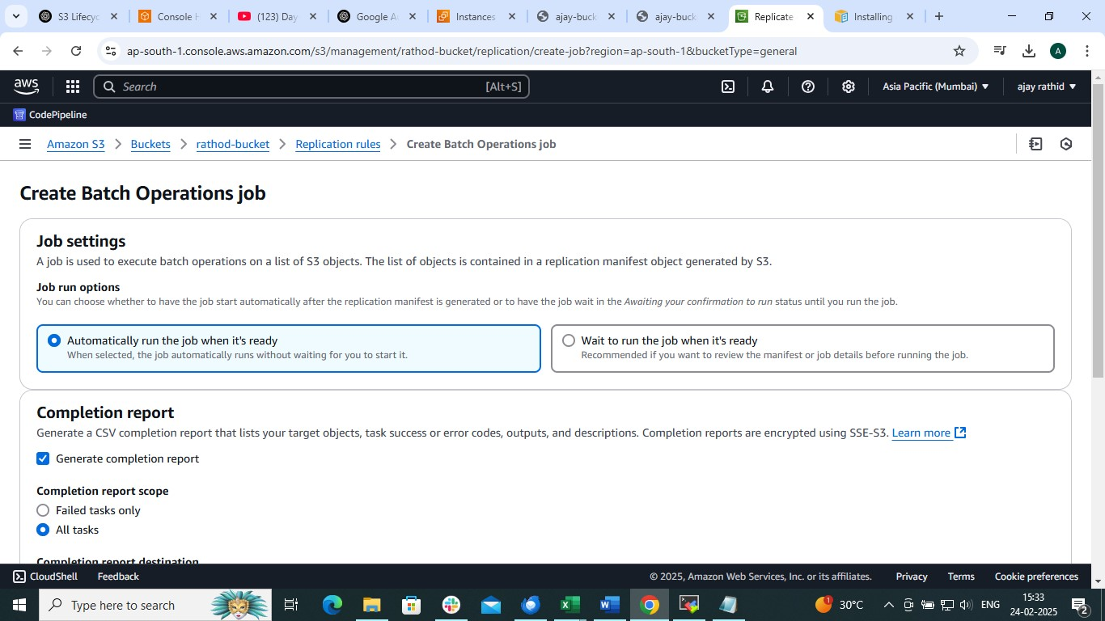

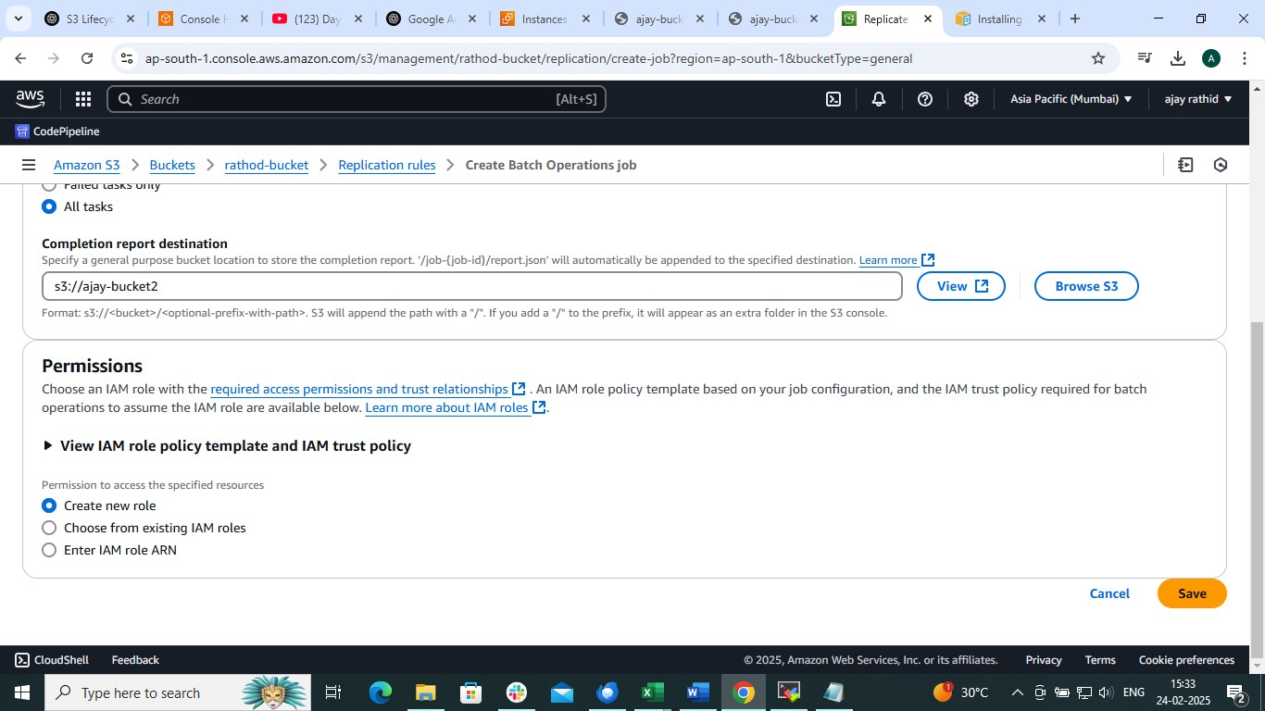

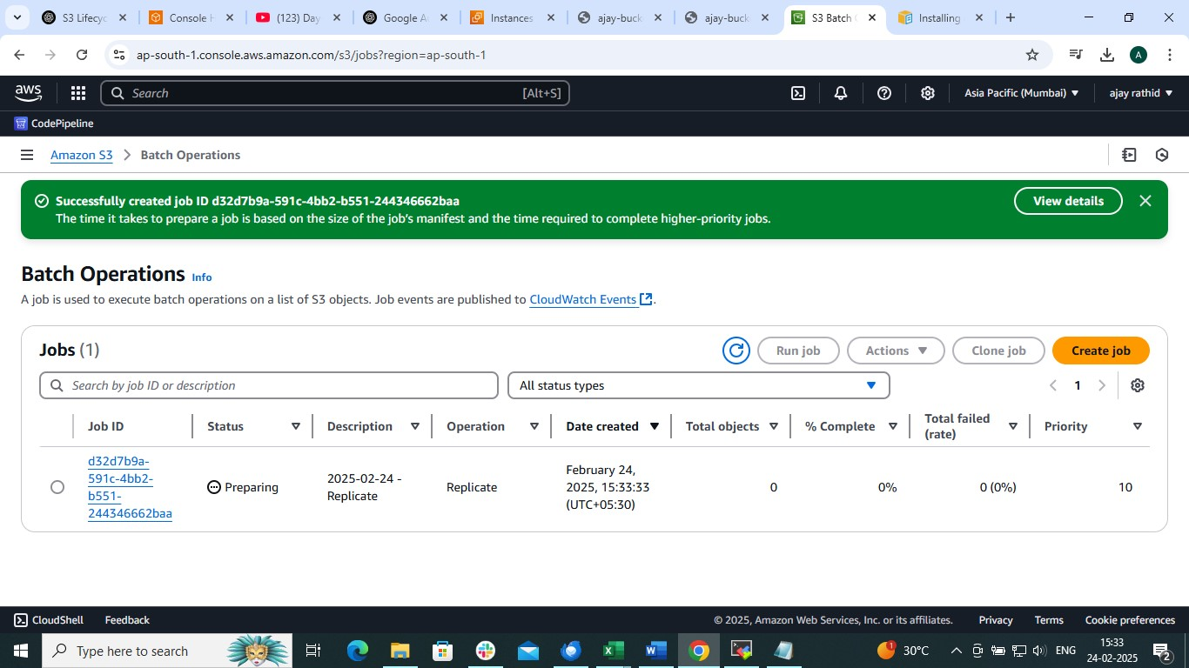

THAT’S IT